**CNN SMALL GRANTS PROGRAM DEMYSTIFIED**



This is in response to comments in the 2016 grants survey. Some of the items below are covered [online](http://cnncoalition.org/?page_id=342) and in the application.

Any suggested changes to the CNN small grants program will be reviewed by our community volunteers.

* In a nutshell what is this grant program about?

The CNN small grants program is part of the City of Portland's Office of Neighborhood Involvement's city-wide small grants program which funds community-driven projects in CNN. This city-wide program is meant to fund small community projects that can be accomplished within 12 months.

* **Goals of the city-wide and the CNN small grants program** 
  + To increase the number and diversity of people who are involved and engaged in their communities.
  + To strengthen community capacity through, for example, leadership development, skills building, fostering teamwork and/or partnerships, and community building.
  + To increase community impact on public decisions.

C:\Program Files (x86)\Microsoft Office\MEDIA\CAGCAT10\j0222015.wmfAbout funding:

* Why doesn’t the CNN small grants program have more funds to go around?
* CNN receives the smallest funding allocation from the City yearly which is largely based on service population size. We stretch these funds and added more funds in 2015 with CNN board support. We recognize the need to raise more funds for projects in the CNN area. Community support will be necessary to achieve this goal.
* The city-wide program is meant to fund small community projects that can be accomplished within 12 months. We understand matching funds may be needed for projects with greater outcomes but this is not a requirement.

* CNN may consider increasing the amounts for projects but that could mean less projects may be funded in our area in a given year.
* There will be a minimum and maximum grant amount in the application.

 About the timeline:

* Why can’t we extend our grant project?
* Grantees have one year to complete their project (for example, Jan 1st, 2016 to Dec 31st, 2016). This is because the grant projects follow an annual timeline which is a city-wide budget requirement.
* All coalitions have a one year grant cycle. It can begin and end at a different time of the year. We are flexible on the timeline (grant deadline and announcements). We will give early notice for grant seekers who do not meet with their boards often.
* When will I know to apply for the next round of grants?

We will give notice after the City budget for the year is approved in June. We will provide subsequent grant announcements in various media including the date of the workshop.

* Do I have to wait for the grant workshop or announcement to get feedback on a project or idea?

No, you can contact the grant manager at any time of the year.

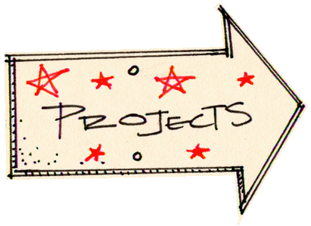About grant making and the projects we fund:

* Can we apply as a group without a fiscal partner?

To increase access for all community groups, the CNN board will consider sponsoring eligible projects of emerging groups without a fiscal partner. This will be clear in future applications.

* Can groups apply for a grant for something they've done before; We would like to apply for the same project more than twice?

We may consider funding the same project more than twice. We will also continue to consider new projects and grant seekers.

* Will you provide support to existing programs, for staff time, and/or for professional services?

We fund a range of community projects, one-time events, and components of existing programs. Staff time and professional services such as outreach, translation, and design work, etc. as well as up to 10% for administrating the grant can be incorporated into the grant proposal budget.

* What projects were funded in the past?

**See** [**online application**](http://cnncoalition.org/?page_id=342)**-page 6.**

* The small grants program is not designed to accommodate requests for ongoing general organizational support such as rent and utilities. We know this is a need especially for emerging groups. We can refer groups to funding sources that may be more suitable.
* Requests to fund community capital projects such as play structures, signs, equipment, planter boxes, and greenery, etc. should include a community building or social component.
* Do we need to partner with another group?

No. It is desirable to partner considering the limited resources available. We understand that not all groups will partner on a community project. We will make this clearer in the application and grant making process.

* We have limited volunteer time to create and implement a project

There are organizations with staff and groups such as neighborhood associations operating with volunteers that can apply for a grant. We are aware that volunteer groups have limited resources available. If you already host a community building event or other planned activity and want to engage community members, please connect with the grant manager about your options.

* Is the workshop required to apply for a grant?

No. You or a person from your group is encouraged to attend. This helps groups with the application process and developing a successful project proposal. Sharing questions and ideas with other participants is very beneficial. If you have a time conflict, you are highly encouraged to contact the grants manager to get feedback on your project.

* How do you select grants?

Through a grant selection committee composed of board members, CBOs and past grant recipients that revolve yearly. The committee recommends awards based on evaluating how the project meets goals and provides a community benefit.

* Can staff help with identifying partnerships or project development?

Absolutely!

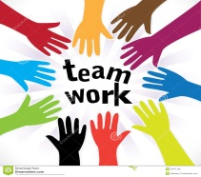 Staying connected:

We are pleased to learn from the community that the grant program is beneficial and that we should continue our current efforts. We also know we can always do better! In order to have a great program we encourage you to continue to stay connected, share ideas, and be involved!